**Task on CloudFront**

**1) Configure VPC peering in cross regions.   
  
Step 1: Create Peering Connection**

1. Log in to AWS Management Console.

2. Navigate to VPC dashboard > Peering Connections > Create peering connection.

3. Select:

- Requester VPC (select your VPC in one region) - California

- Accepter VPC (select your VPC in another region) - Ohio

4. Create peering connection.

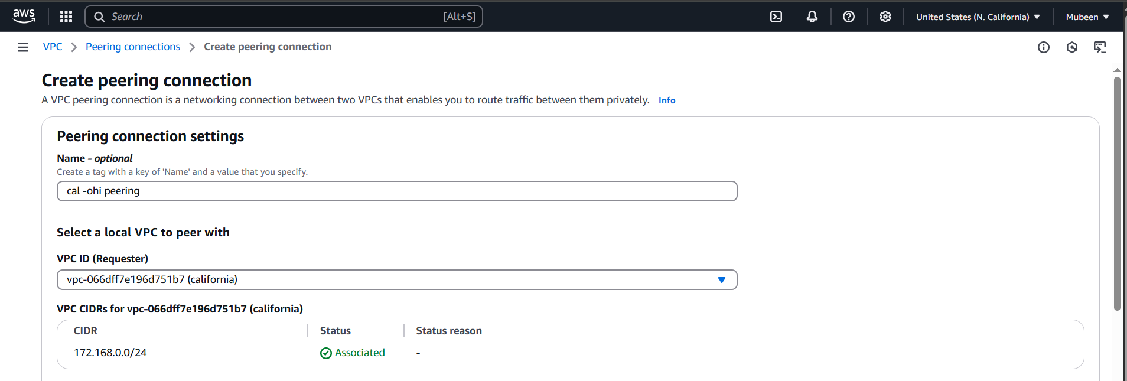

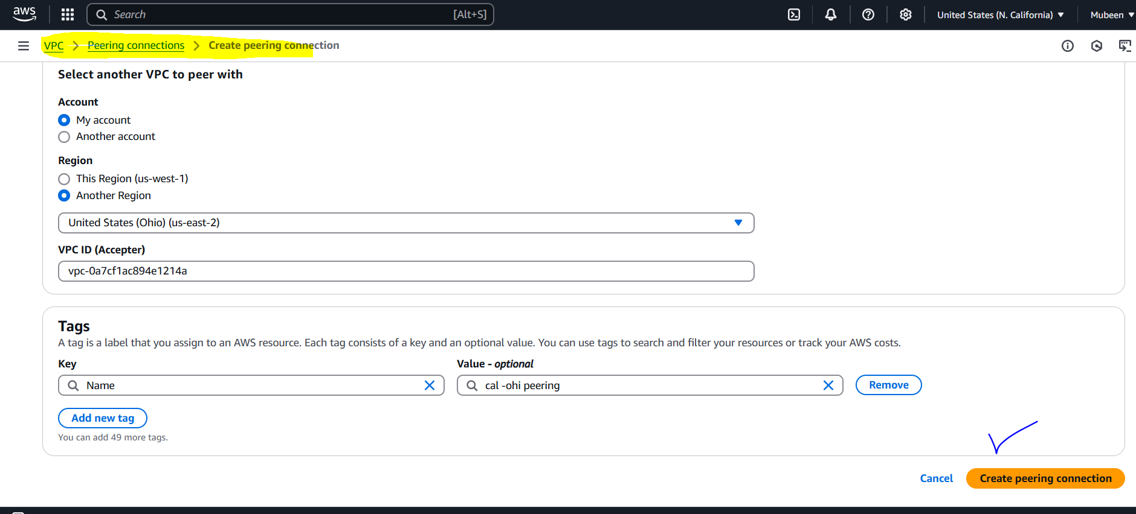

**Step 2: Accept Peering Connection**

1. Go to Peering Connections.

2. Find the pending peering connection.

3. Accept the peering connection.

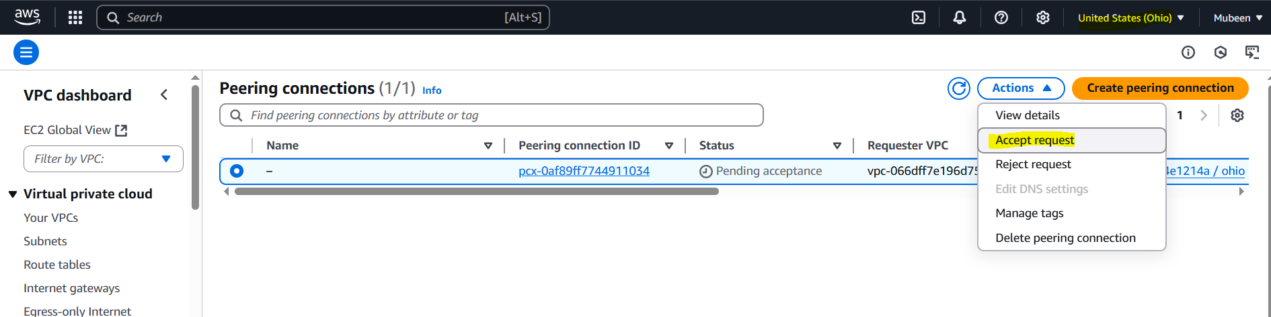

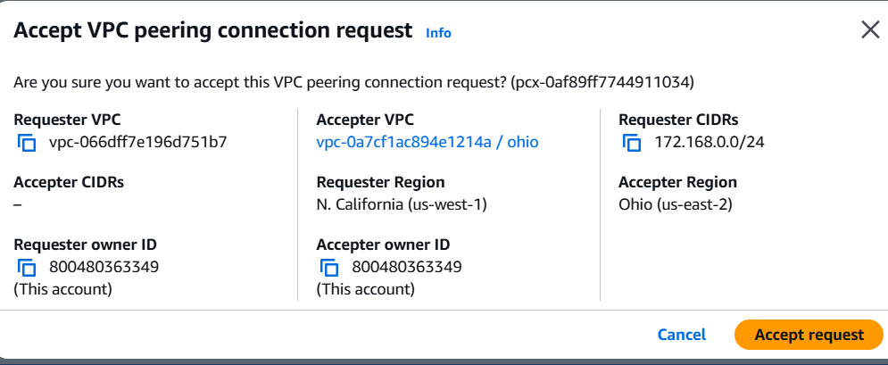

**Step 3: Update Route Tables**

1. Go to Route Tables.

2. Select the route table associated with the requester VPC.

3. Add a route to the accepter VPC's CIDR block.

4. Repeat for the accepter VPC's route table.

**Vpc – California RT**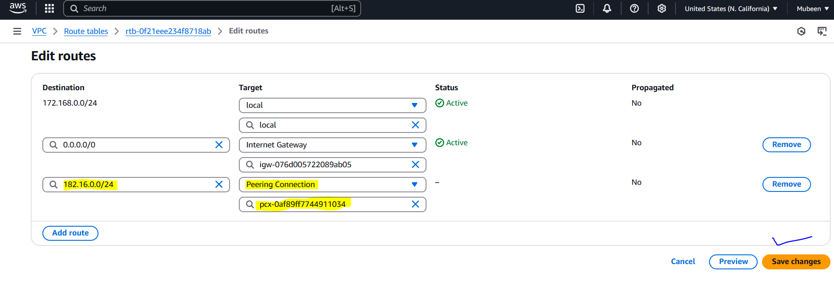

**Vpc – Ohio RT**

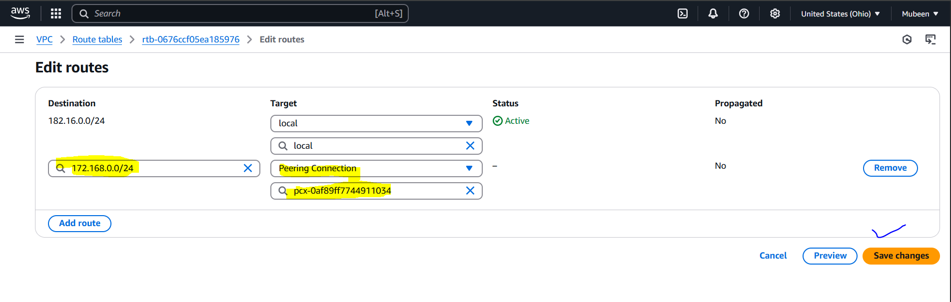

**Step 4: Test Peering Connection**

1. SSH into the public instance in California.

2. Ping the private IP of the instance in Ohio.

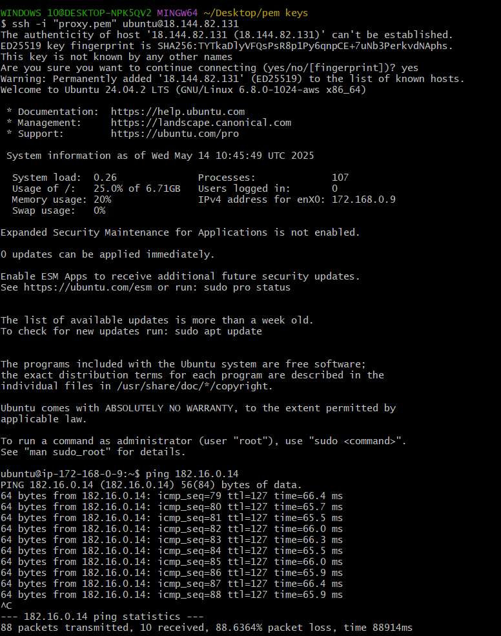

Public server details for reference of vpc, subnet and IP.

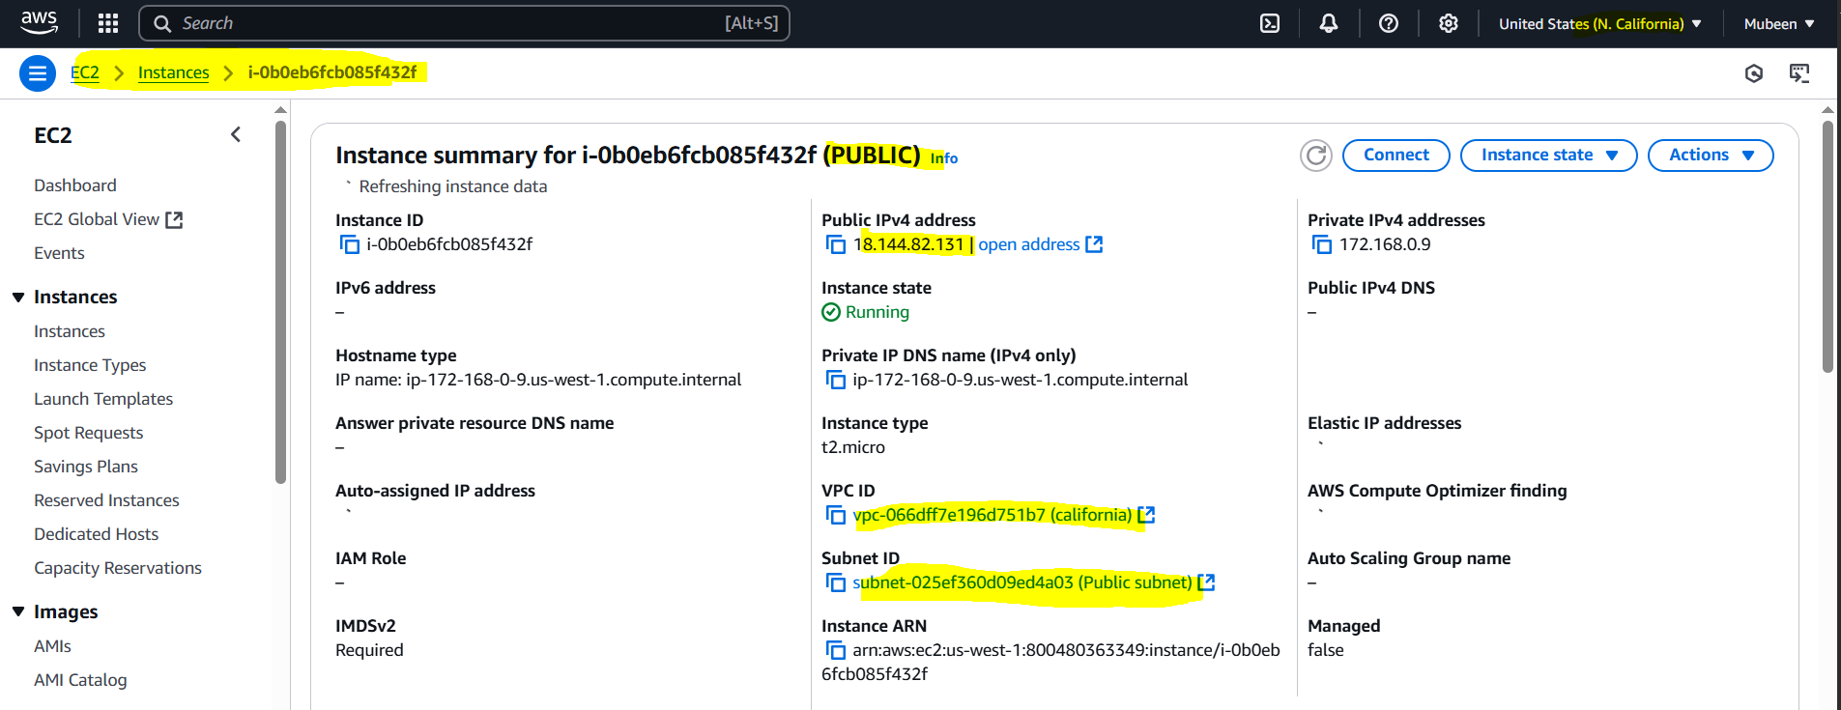

Private server details for reference of vpc, subnet and IP.

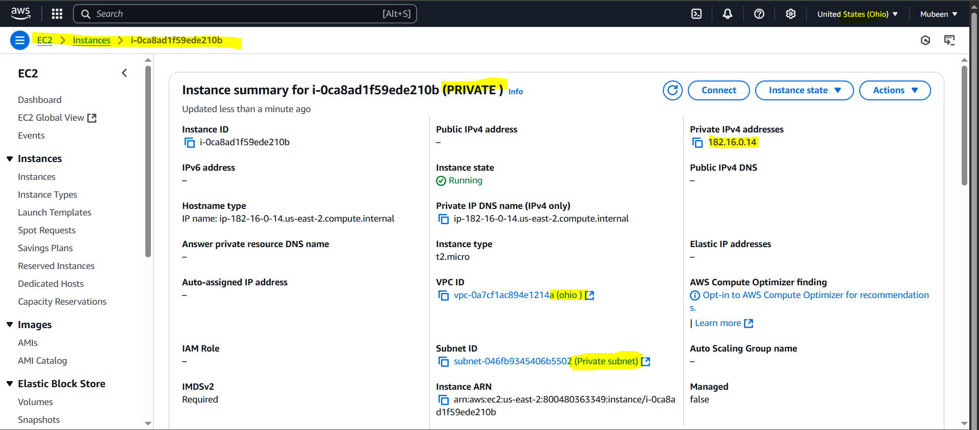

**2) Purchase one domain from godaddy.   
  
Step 1: Search for Domain Availability**

1. Go to GoDaddy's website.

2. Enter your desired domain name in the search bar.

3. Click "Search" to check availability.

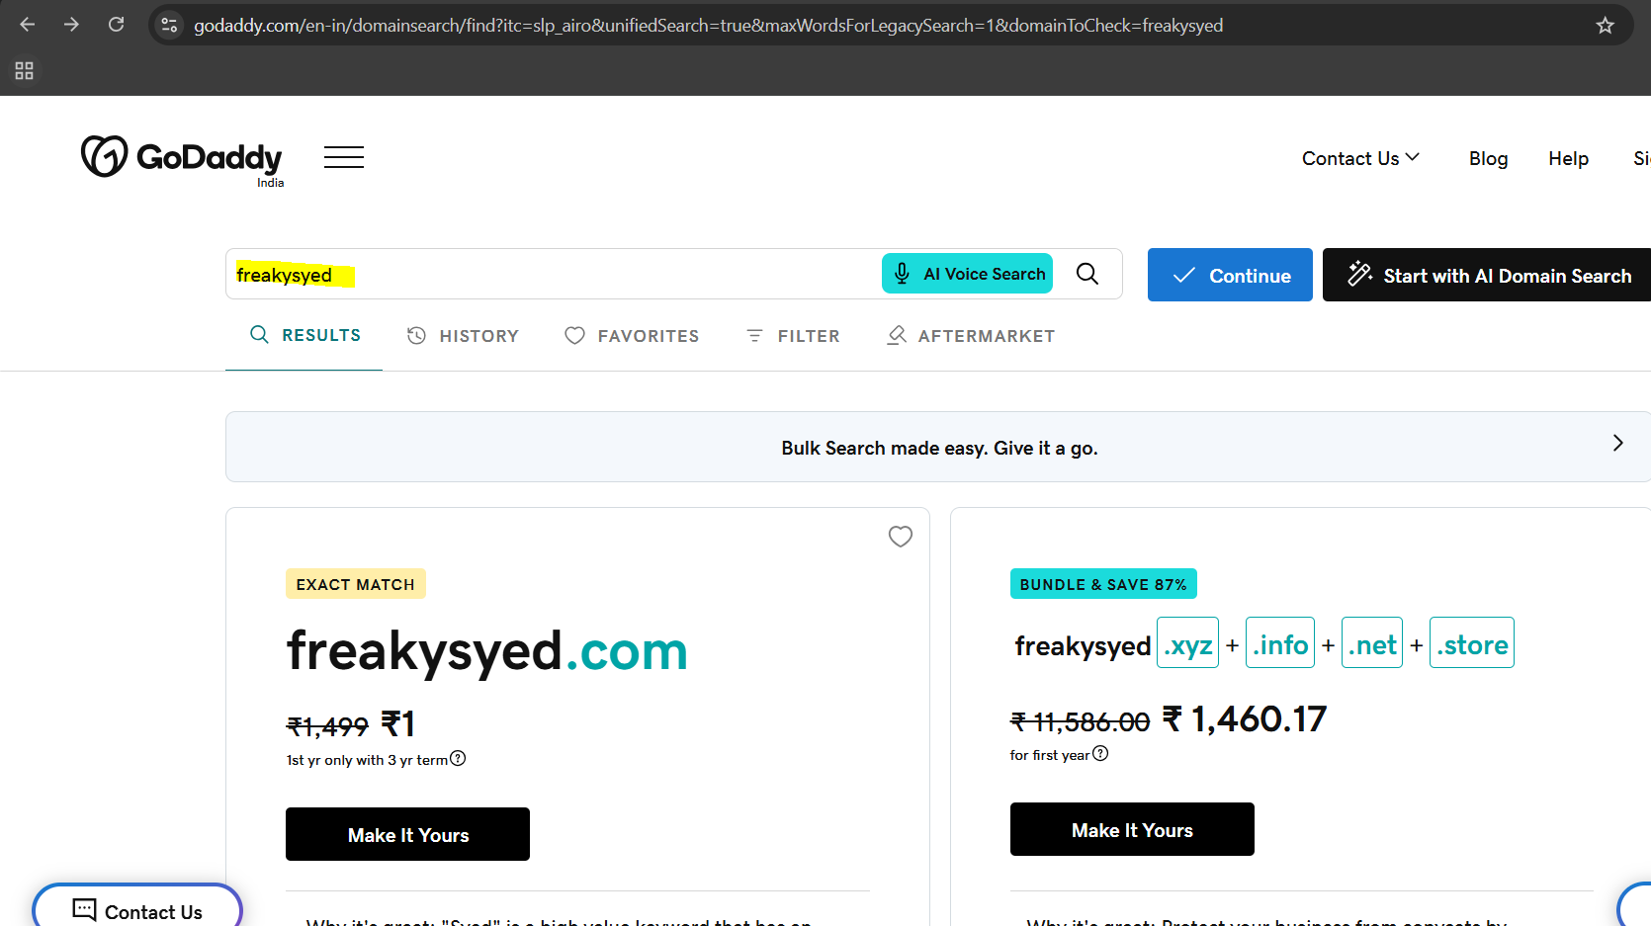

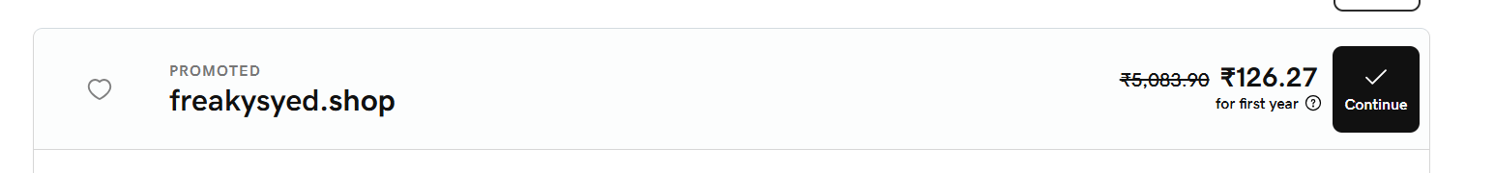

**Step 2: Register the Domain**

1. If available, click "Add to Cart" or "Buy Now".

2. Choose registration period (1-10 years).

3. Review and agree to terms.

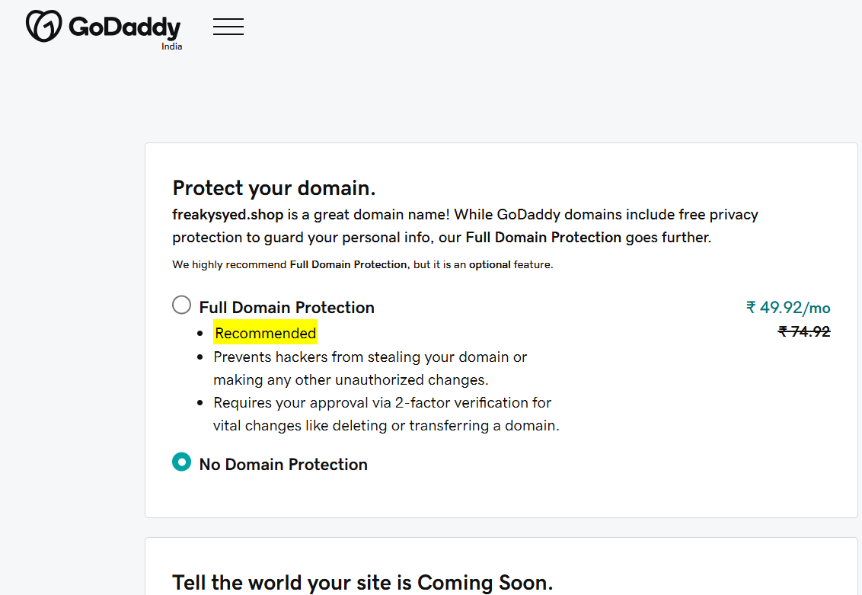

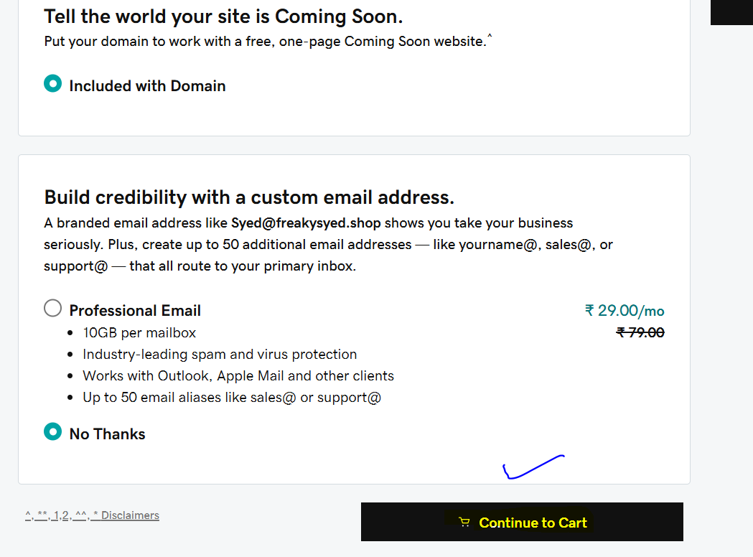

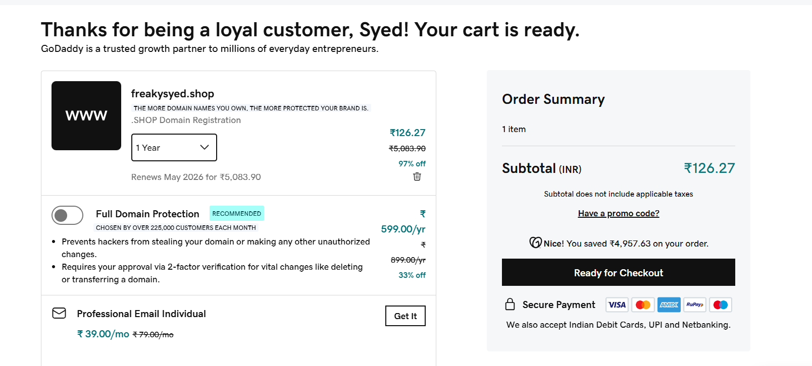

**Step 3: Complete Purchase**

1. Provide contact information.

2. Pay for domain registration.

3. Receive confirmation email.

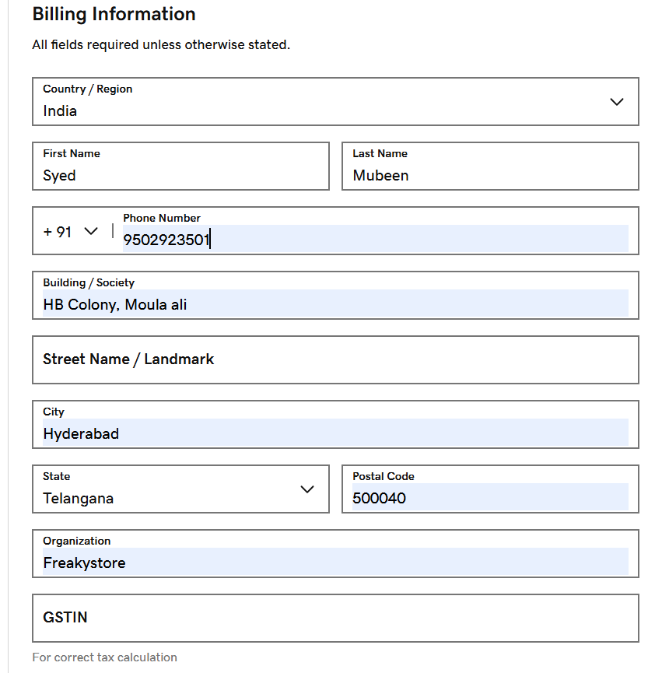

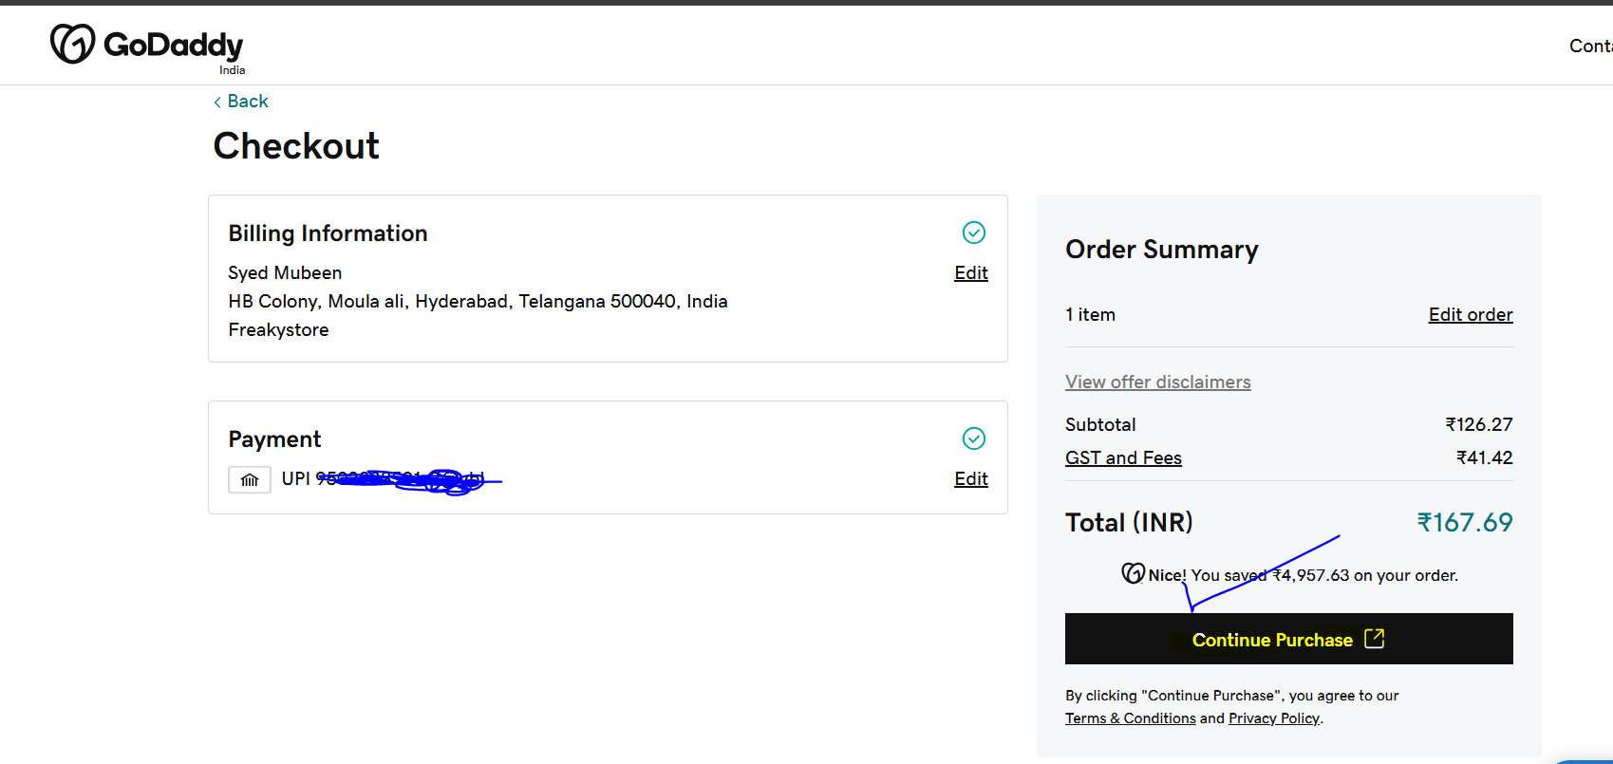

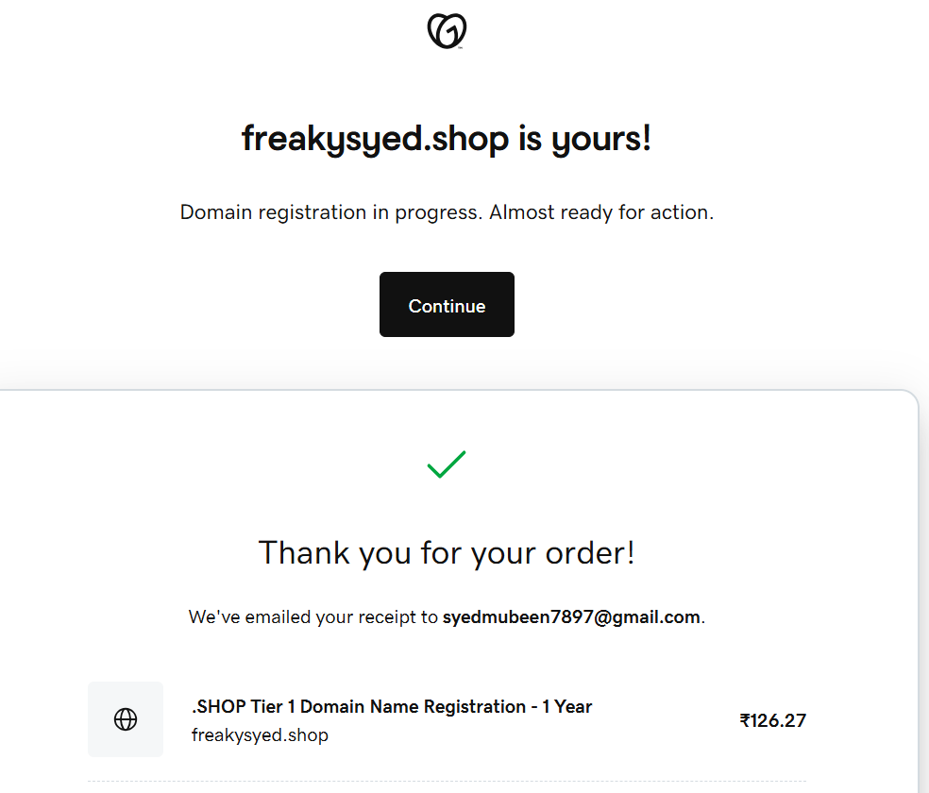

**Step 4: Verify Domain Ownership**

1. Check email for verification link (if required).

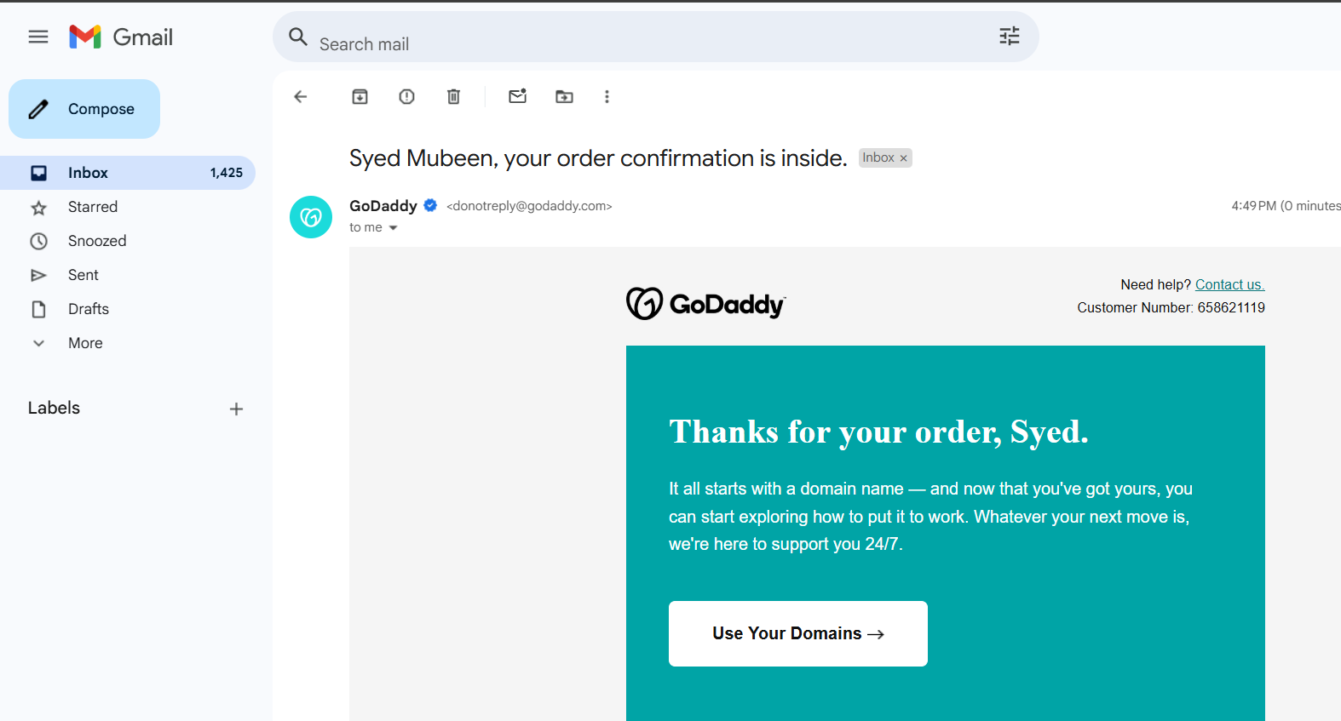

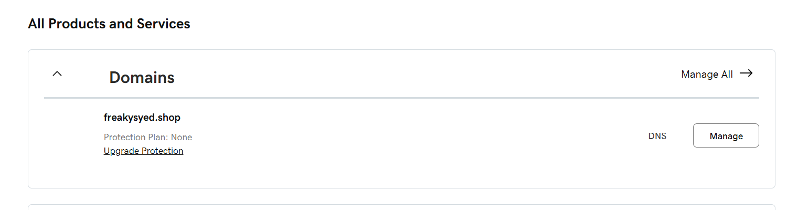

**3) Deploy static website in s3.   
  
Step 1: Create S3 Bucket**

1. Log in to AWS Management Console.

2. Navigate to S3 dashboard.

3. Click "Create bucket".

4. Enter bucket name (e.g., your domain name).

5. Choose region.

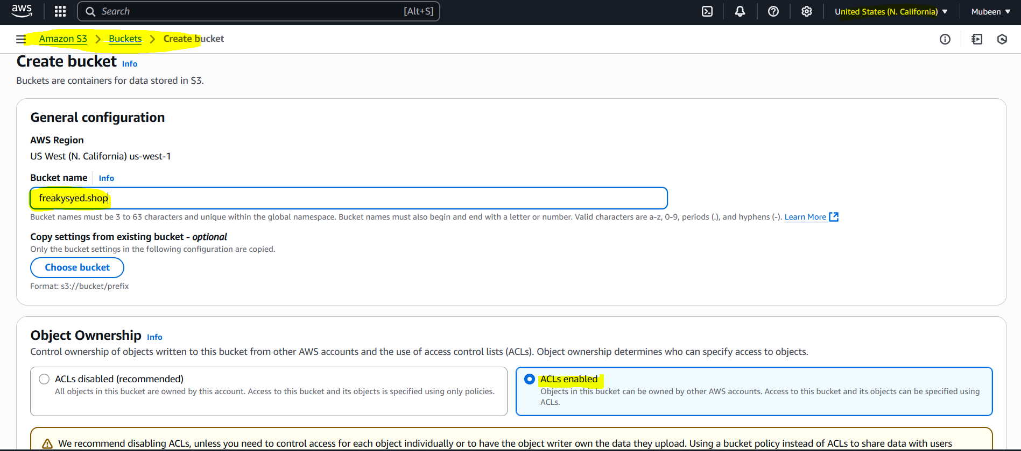

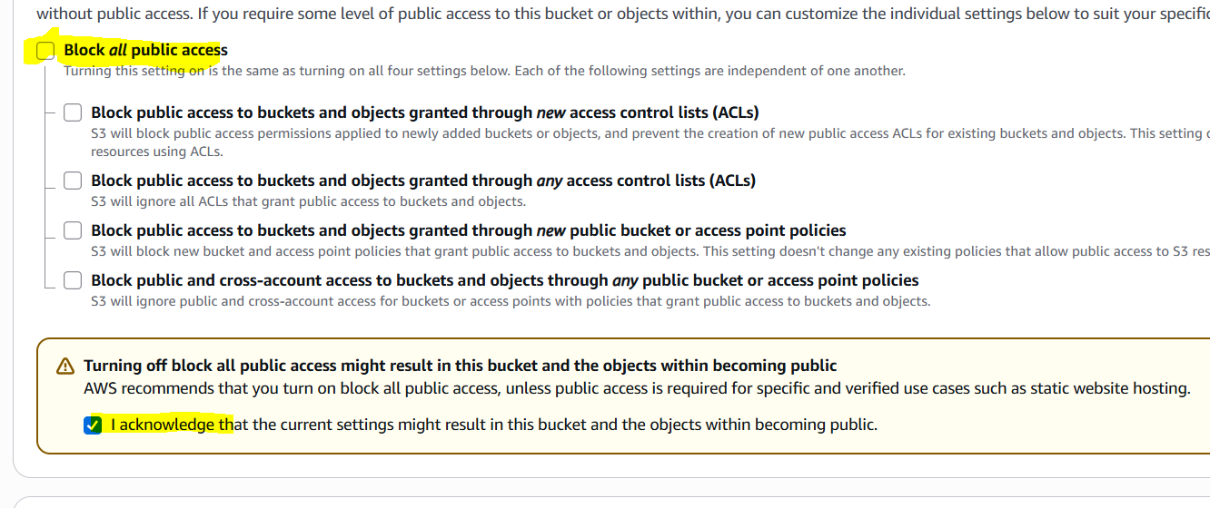

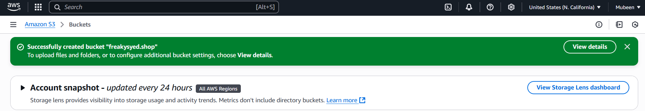

**Step 2: Upload Website Files**

1. Go to your S3 bucket.

2. Click "Upload".

3. Select your website files (e.g., HTML, CSS, images).

4. Upload files.

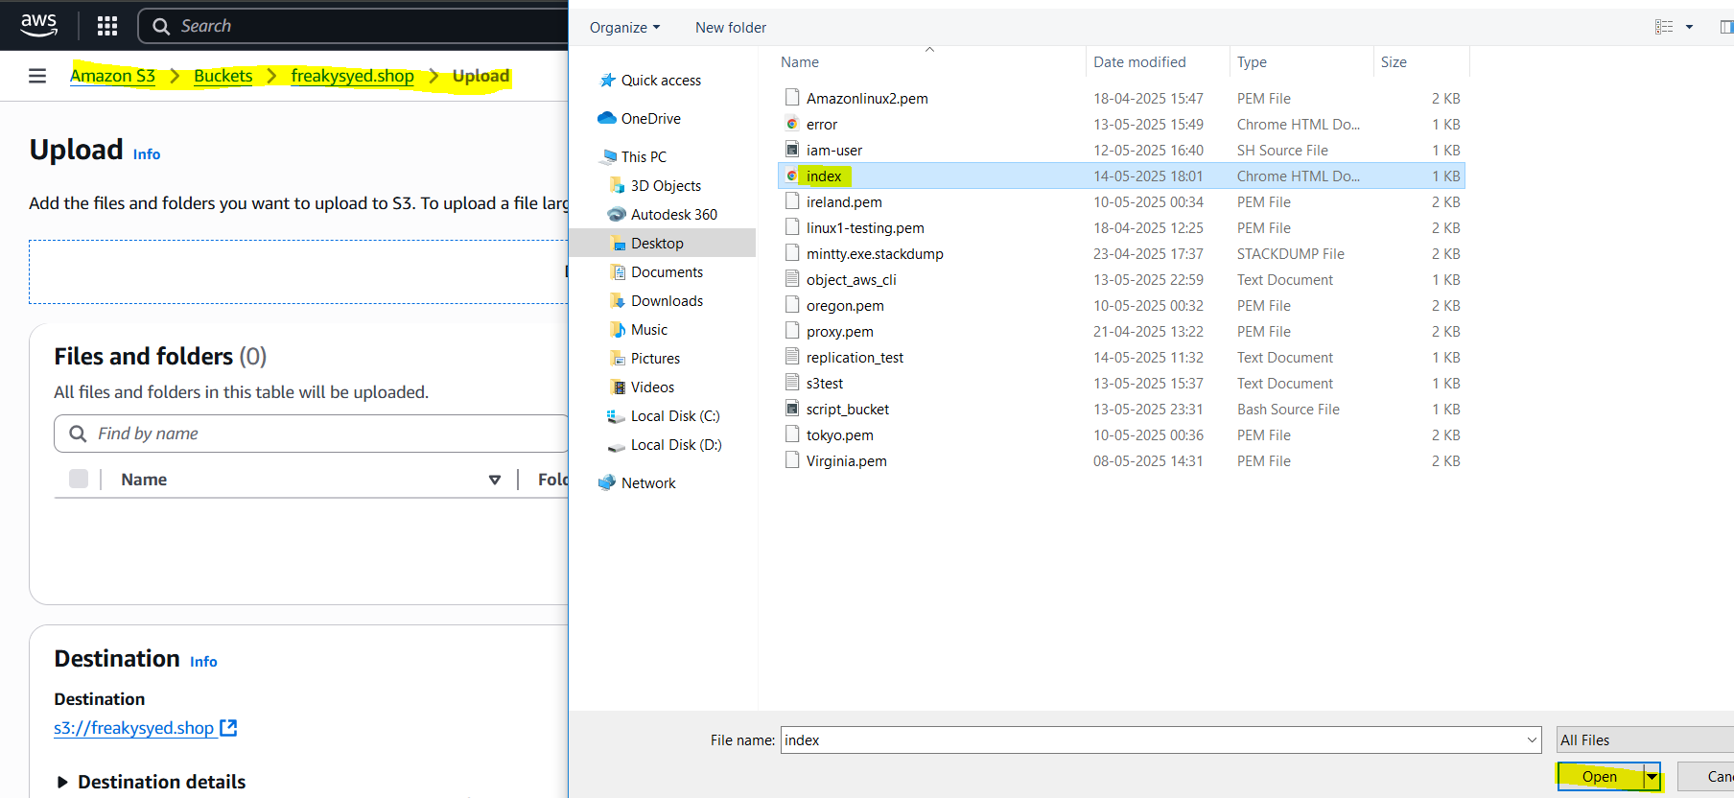

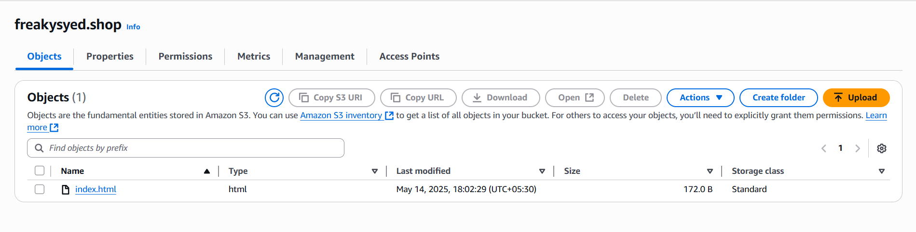

**Step 3: Configure Static Website Hosting**

1. Go to your S3 bucket > Properties.

2. Click "Static website hosting".

3. Select "Enable".

4. Enter index document name (e.g., index.html).

5. Save changes.

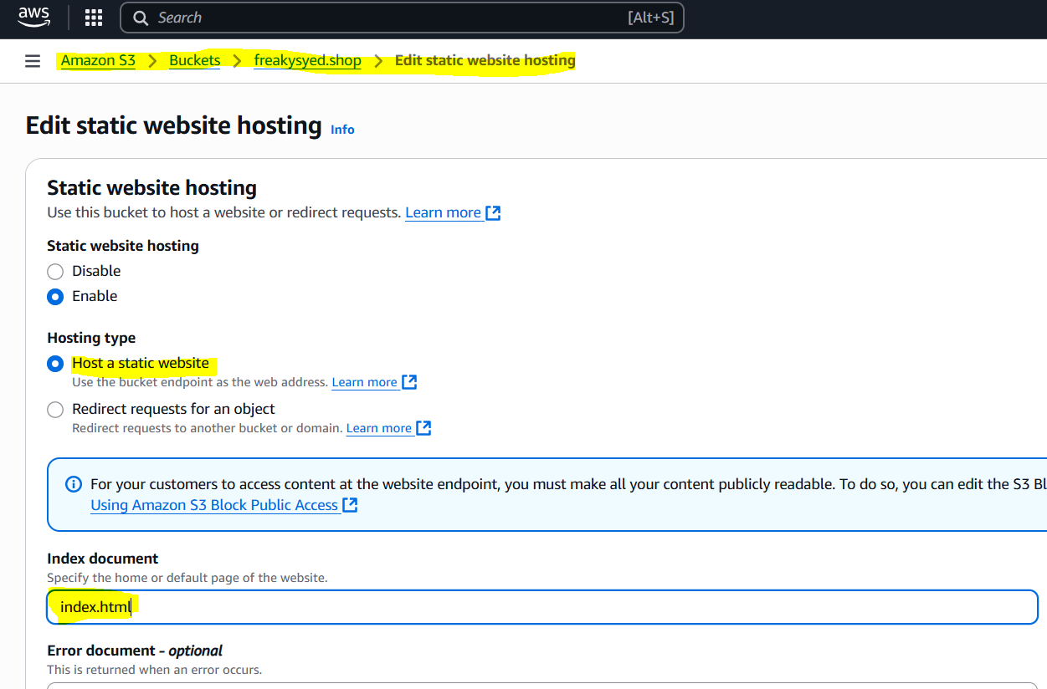

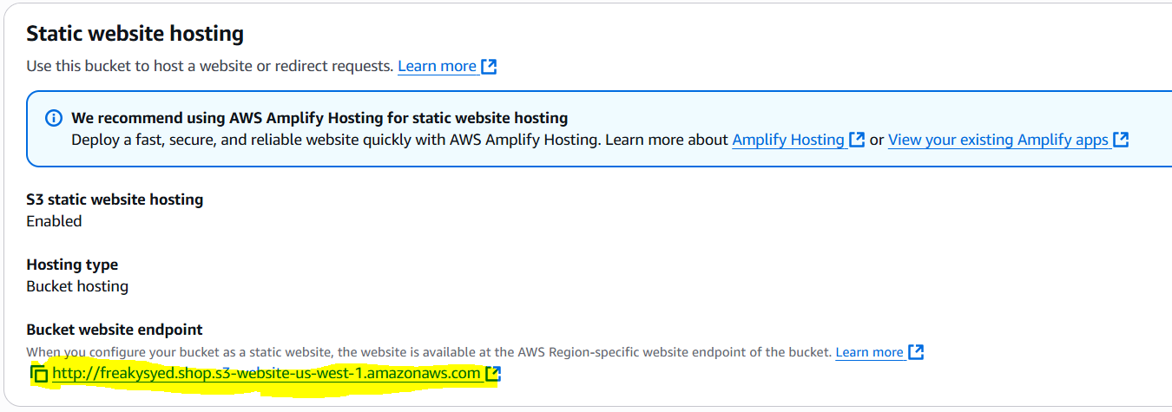

**Step 4: Make Bucket Public**

1. Go to your S3 bucket > Permissions.

2. Click "Bucket Policy".

3. Add policy to allow public access:

{

"Version": "2012-10-17",

"Statement": [

{

"Sid": "PublicReadGetObject",

"Effect": "Allow",

"Principal": "*",

"Action": "s3:GetObject",

"Resource": "arn:aws:s3:::freakysyed.shop/*"

}

]

}

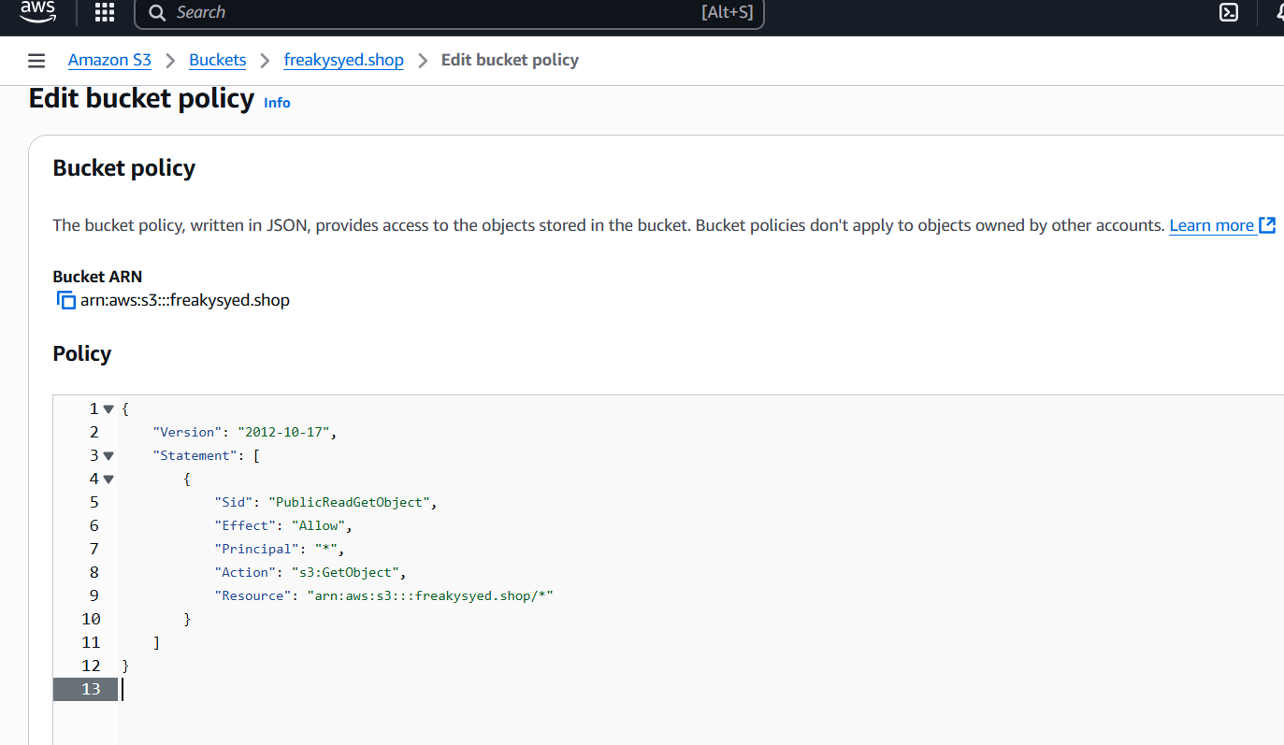

**Step 5: Test Website**

1. Go to S3 bucket > Properties > Static website hosting.

2. Click on the endpoint URL to test your website.

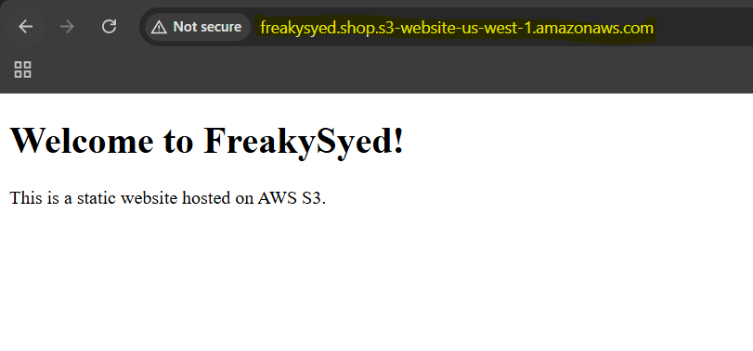

**4) Create CDN and attach one SSL certificate.   
  
Step 1: Create CloudFront Distribution**

1. Log in to AWS Management Console.

2. Navigate to CloudFront dashboard.

3. Click "Create Distribution".

4. Select "Web" distribution type.

5. Choose your S3 bucket (freakysyed.shop) as the origin.

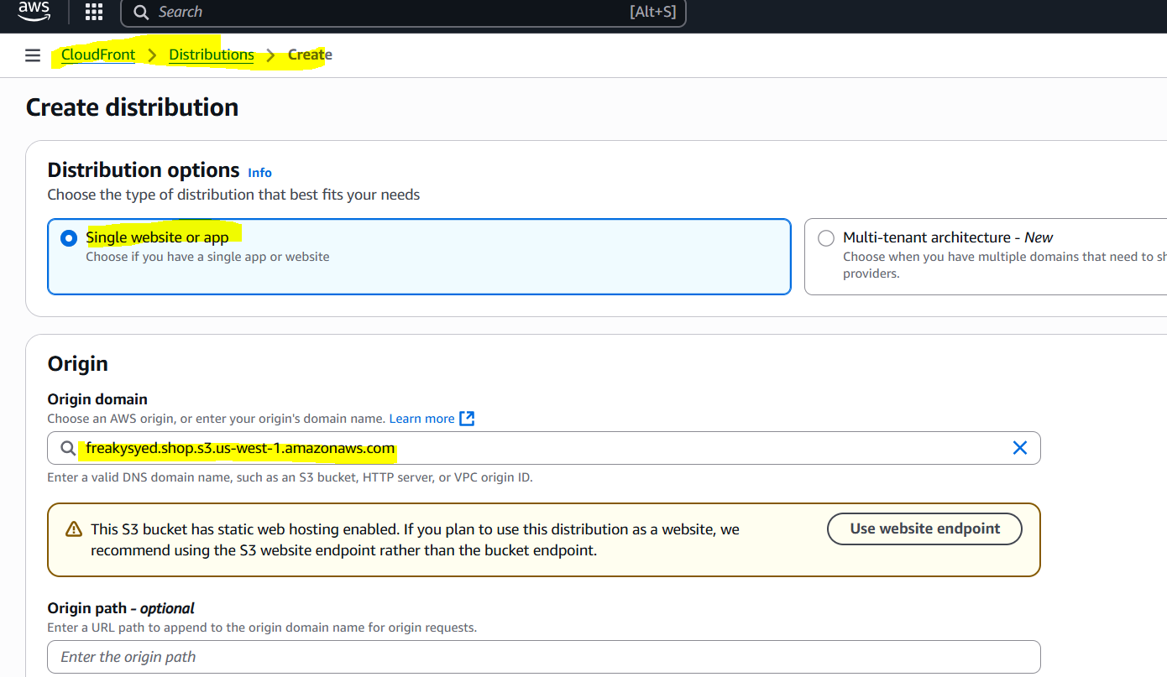

**Step 2: Configure Distribution Settings**

1. Enter distribution settings:

2. Choose "Redirect HTTP to HTTPS" for Viewer Protocol Policy.

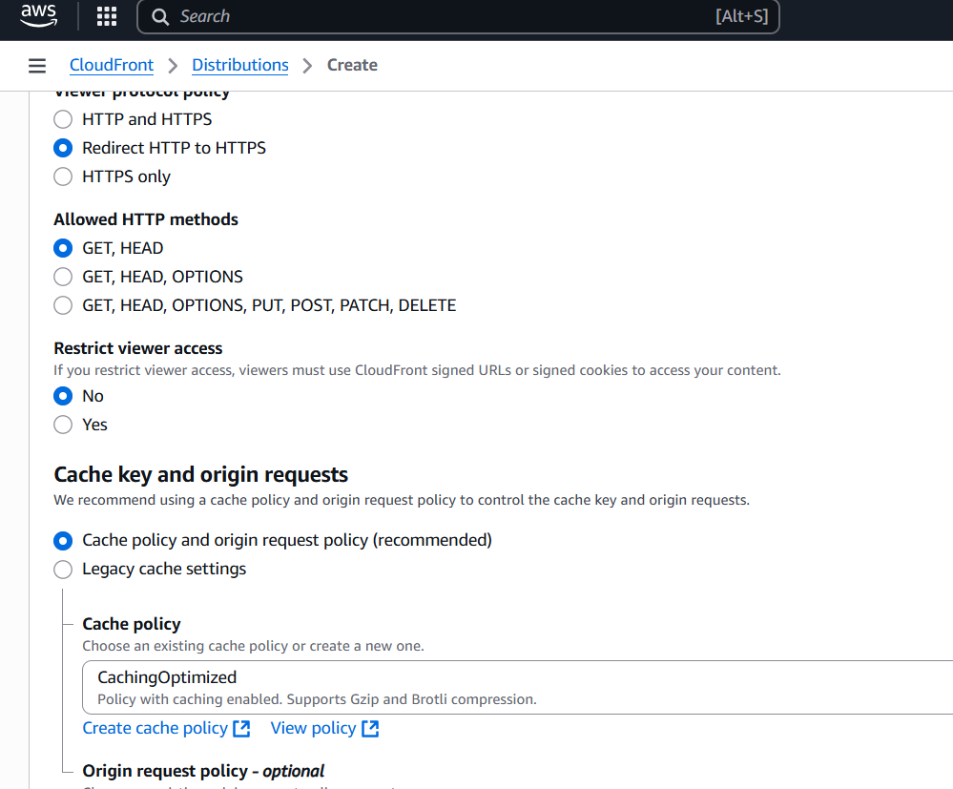

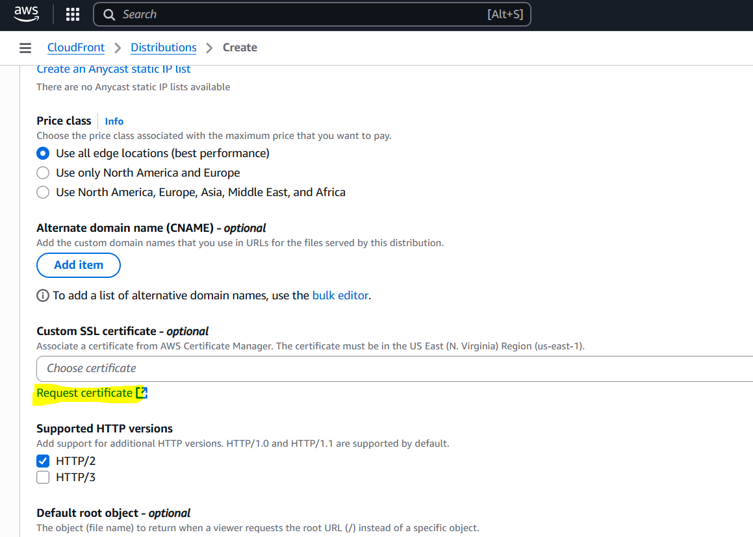

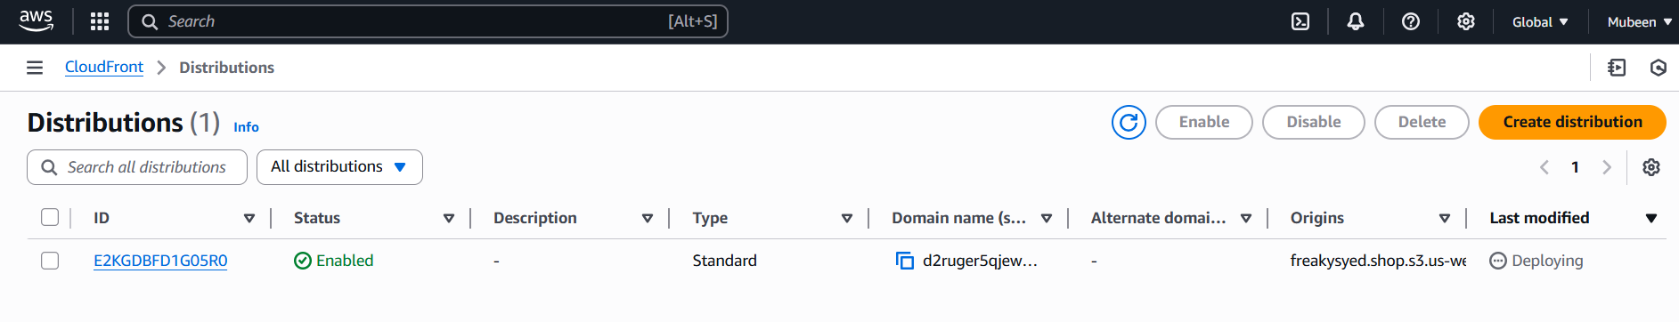

**Step 3: Create SSL Certificate (ACM)**

1. Navigate to AWS Certificate Manager (ACM).

2. Click "Request a certificate".

3. Choose "Request a public certificate".

4. Enter your domain name (freakysyed.shop).

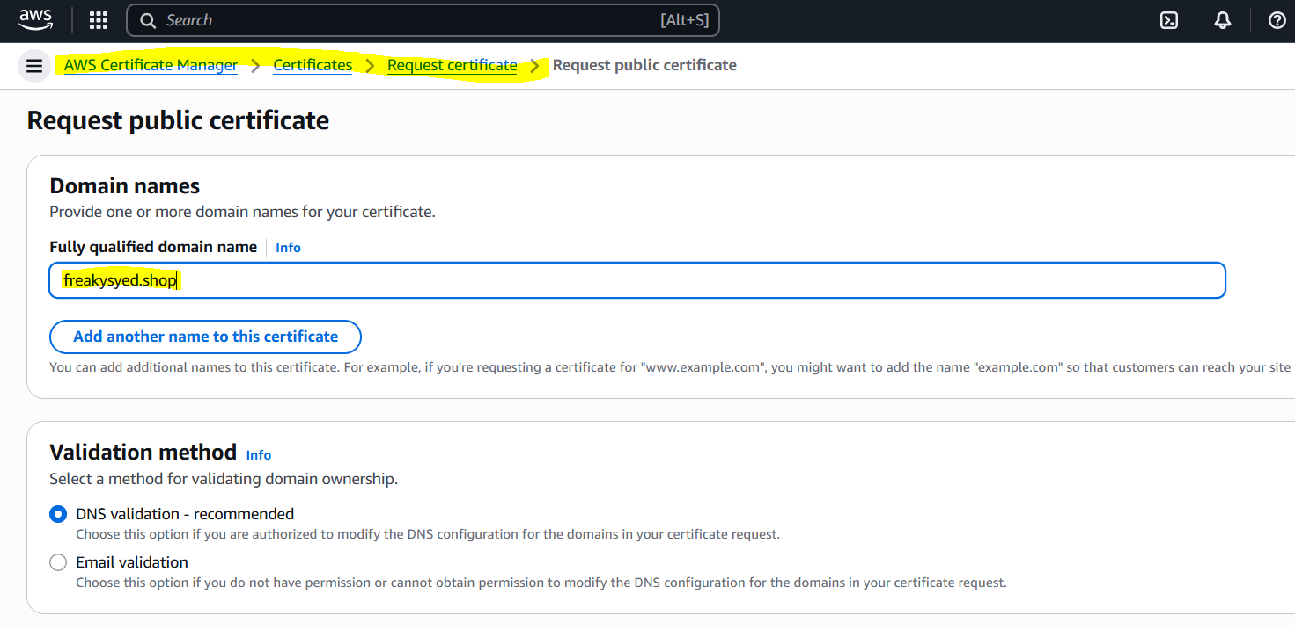

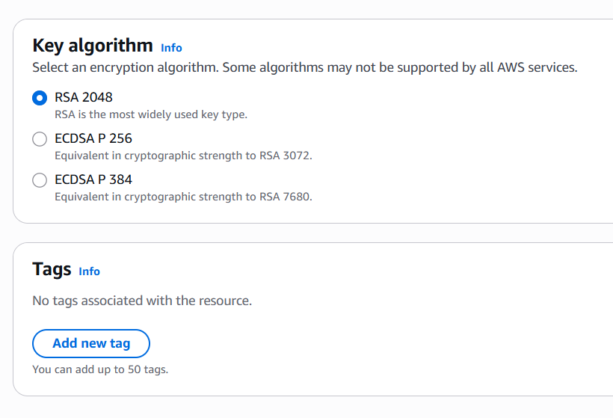

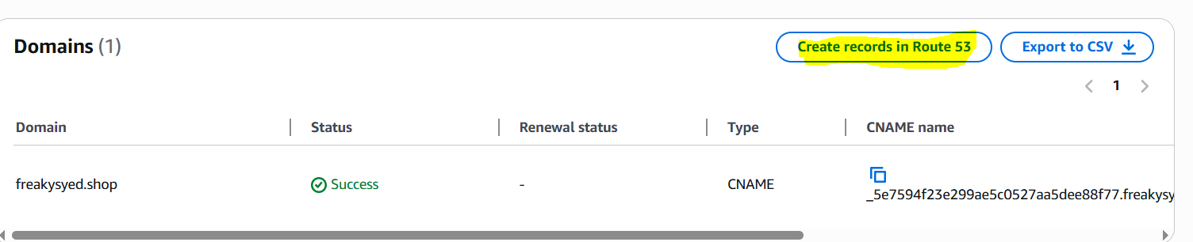

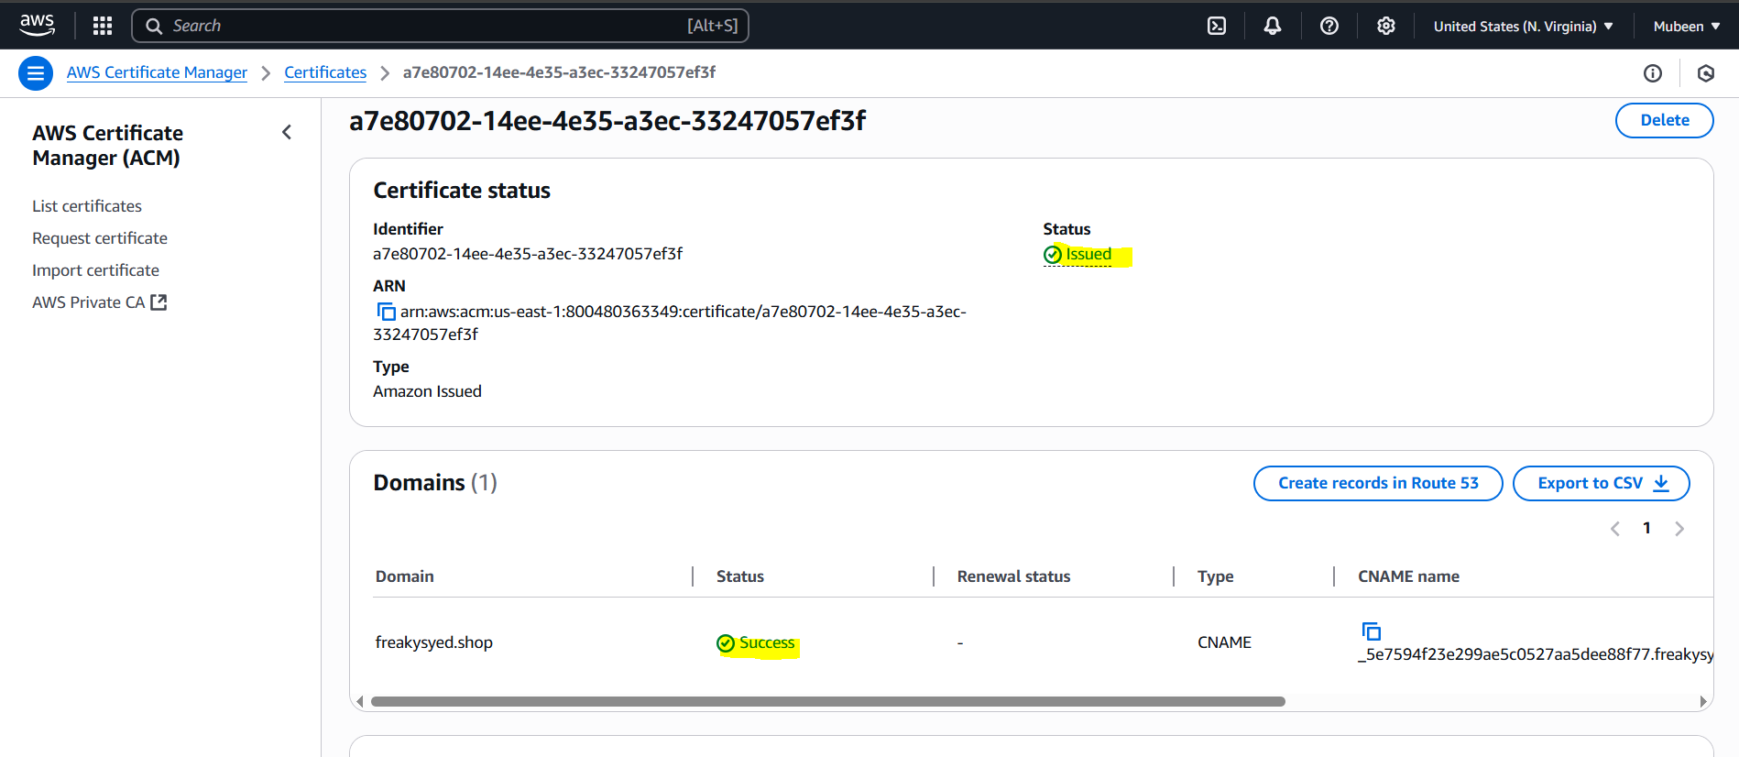

**Step 4: Attach SSL Certificate to CloudFront**

1. Go back to CloudFront dashboard.

2. Select your distribution.

3. Click "Edit" in the "General" tab.

4. Choose "Custom SSL Certificate" and select your ACM certificate.

5. Save changes.

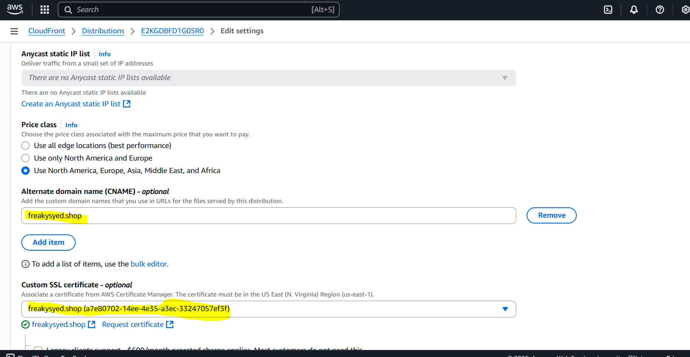

**5) Create Route53 hosted zone and MAP the domain with CDN.   
  
Step 1: Create Hosted Zone in Route 53**

1. Log in to AWS Management Console.

2. Navigate to Route 53 dashboard.

3. Click "Create a hosted zone".

4. Enter your domain name (freakysyed.shop).

5. Click "Create hosted zone".

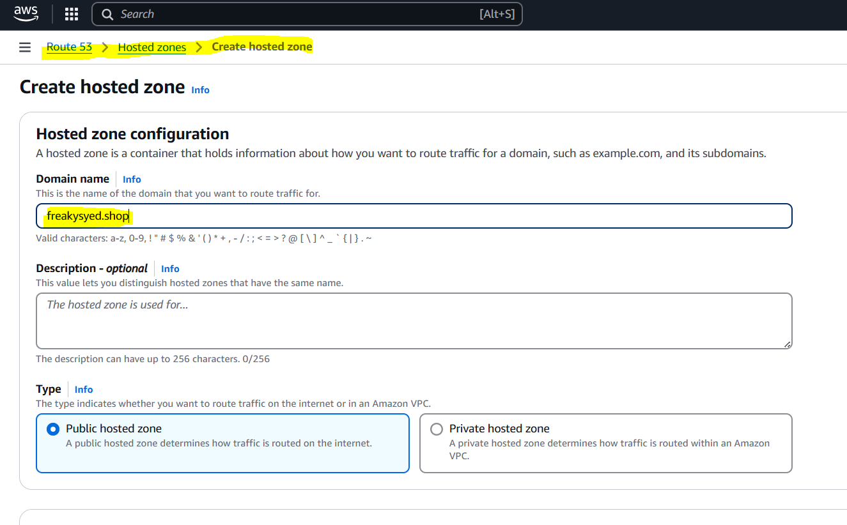

**Step 2: Create Record for CloudFront**

1. In the hosted zone, click "Create record".

2. Choose "Alias" record type.

3. Select "Alias to CloudFront distribution".

4. Choose your CloudFront distribution.

5. Click "Create records".

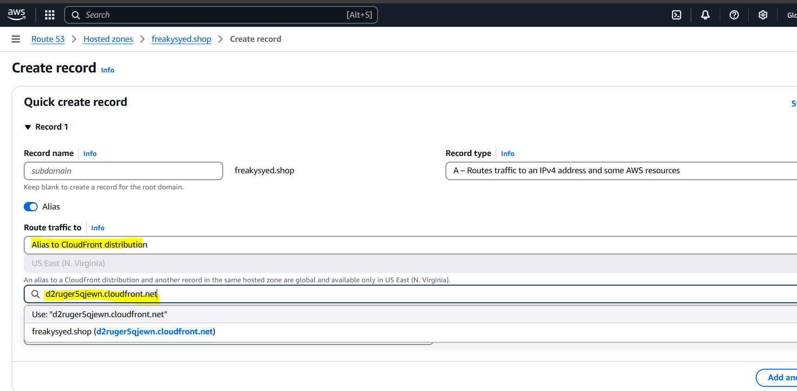

**Step 3: Update Name Servers (if needed)**

1. If you're using a domain registrar other than Route 53, update the name servers to point to Route 53.

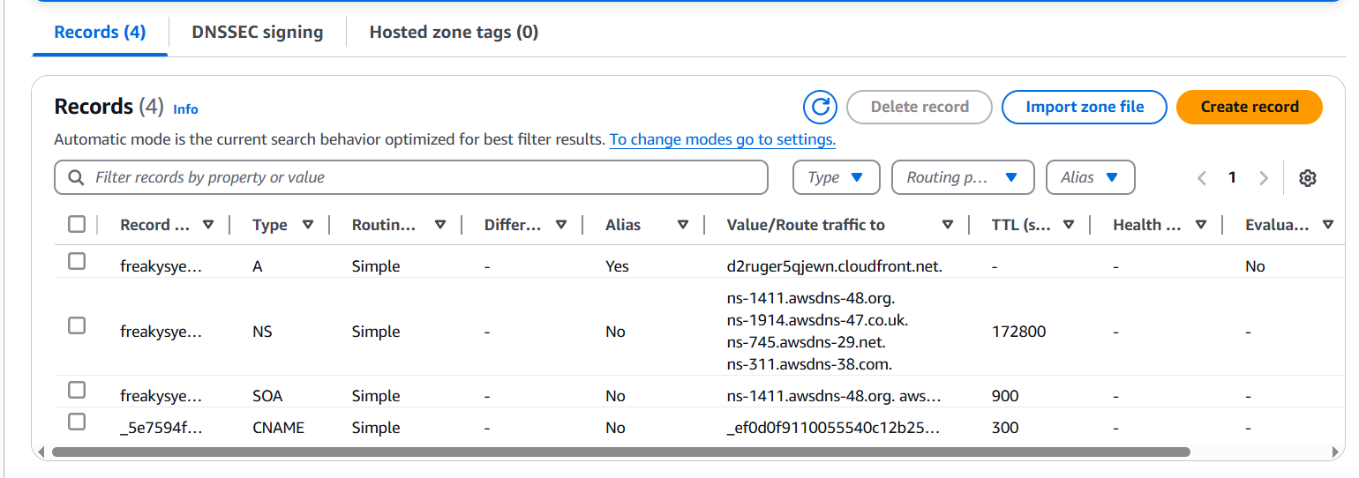

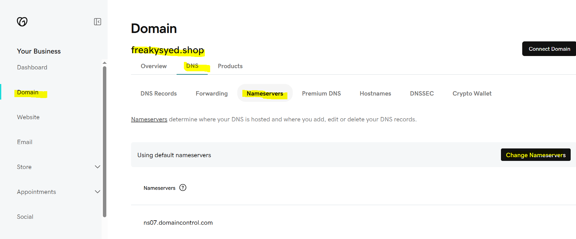

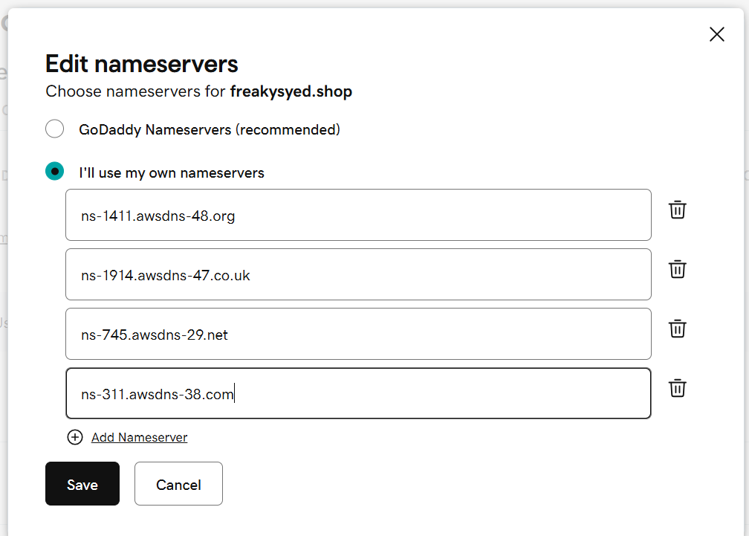

**6) Update the index.html in s3 bucket and the updated file should be accessible by using domain name.**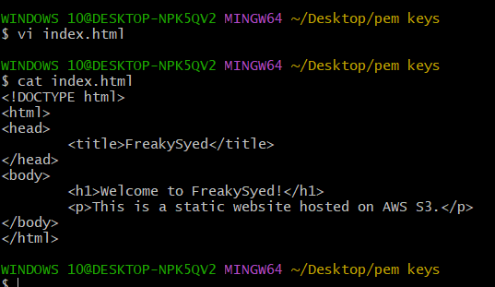



Already added to the bucket.

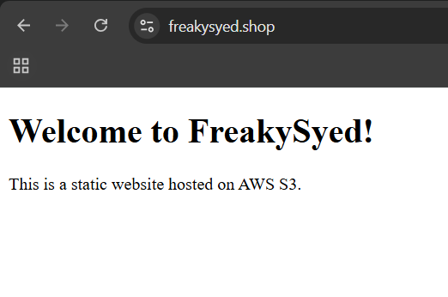

Successfully completed the task.

**7) Share the Domain name in slack to test the connectivity.**Document and Domain name both are shared into Slack status channel.

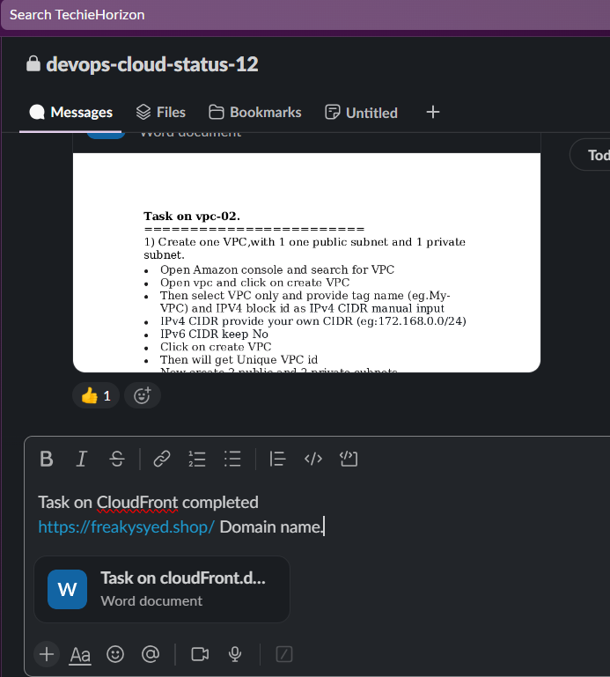

**The-End**